Sponsorship Registration Form

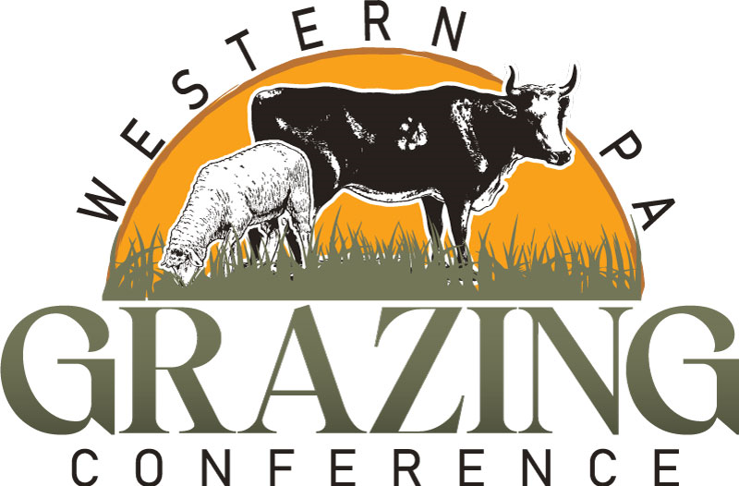
Presented by the Western PA Grazing Conference Committee

March 12, 2026

Trinity Point Church of God
180 West Trinity Drive, Clarion, PA

Register & pay online at www.westernpagrazing.com or send registrations with check payable to:
Clarion Conservation District
249 S 2nd Avenue Clarion PA 16214
Sponsorship Registrations due by February 20, 2026

Platinum: $650 = Vendor Space + 4 name registrations (includes meals), + 6 min. speaking opportunity.
Gold: $500 = Vendor Space + 3 name registrations (includes meals) + 4 min. speaking opportunity.
Silver: $250 = Vendor Space + 2 name registrations (includes meals), + 2 min. speaking opportunity
Bronze: $150 = Event Sponsorship

* Additional Registration - $45 each
------------------------------------------------------------------------------------------------------------------------------------------------------------------------------------
Vendor/Sponsor Name:

Number Attending

Dollar Amount
Included:

Attendees N
ame(s):

Business Address:

Primary Contact Person:
Email
:

Phone:

Fax:

Require access to an
electrical outlet?

Y

N

Donating a Door Prize:

Y

N

If yes/known,

please list:

